Name : Ahmad Mustafa
B-III Artificial Intelligence ( Evening )
Sir Adeel

Command = chmod
The chmod (change mode) command in Linux/UNIX is used to modify file and directory permissions. It controls who can read, write, or execute a file by setting access rights for the owner, group, and others.
- Used to change permissions of files and directories
- Manages access for owner, group, and others
- Controls read (r), write (w), and execute (x) permissions
- Helps maintain system security and proper access control

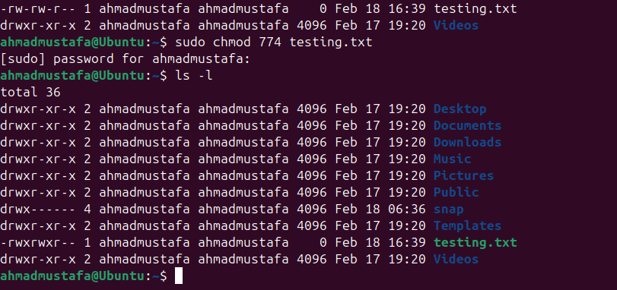

Command = ps
Listing running processes in Linux helps you monitor and manage all active programs and system tasks.
- Linux provides commands to view active processes and their details like PID, CPU, and memory usage.
- The most common command is ps, which shows currently running processes.
- top displays real-time updates of system processes and resource usage.
- htop offers an interactive, color-coded view for easier process management.
- These tools help in diagnosing system performance issues or terminating unresponsive processes.

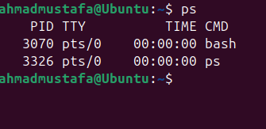

Command = Kill id by PID
The kill command in Linux is used to send signals to processes for managing their execution, typically to terminate them. It can gracefully stop, pause, or forcefully end a process based on the signal sent.

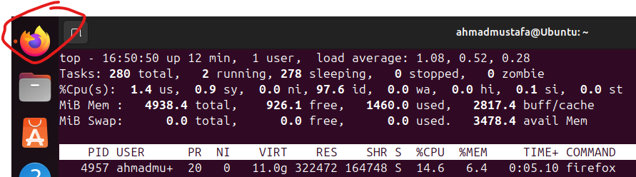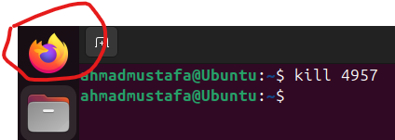

Command = sudo apt update
apt update updates the cache. After that you can actually upgrade the software packages with: $ sudo apt upgrade.

